Where’s That Bridge?
1. Lyme Street & I95 – Arch Concrete - Overpass 1948 [243]
2. Duck River & Library Lane - Single Culvert Bridge
3. Duck River & McCurdy Road - Single Culvert Bridge
4. McCurdy Road & Railroad - Stone & Steel Overpass
5. Railroad & Rte.156 – Steel Stringer - Overpass 1957 [1396]
6. Duck River & Railroad - Stone & Steel Bridge
7. Duck River & Rte. 156 - Steel Bridge
8. Lieutenant River & Rte. 156 – Box Beam – Bridge 1961 [1392]
9. Lieutenant River & Railroad - Stone & Steel Bridge 1961 [1394]
10. Rte. 156 & I95 - Steel Stringer Multi-beam - Overpass 1992 [6173]
11. Lieutenant River & Halls Road – Concrete Box Beam – Bridge 1941, 1995 [1013]
12. Lieutenant River & I95 - Steel Stringer Multi-beam -Bridge 1948, 1991 [6032]
13. Lower Mill Brook & Sill Lane #1 - Box Culvert – Bridge 1982 [4739]
14. Mill Brook & Sill Lane #2 - Box Culvert – Bridge 1982 [4818]
15. Four Mile River & Boston Post Road - Triple Culvert Bridge & Dam
16. Creek Feeding Rogers Lake & Boston Post Road - Reinforced Concrete Bridge
17. Creek Feeding Rogers Lake & Grassy Hill Road - Double Culvert Bridge
18. Rogers Lake Dam, Mill Brook & Town Woods Road - Box Culvert Bridge 1982 [4738]
19. Black Hall Brook & Whippoorwill Road - Single Culvert Bridge
20. McCullogh Farm Creek & Whippoorwill Road - Double Culvert Bridge
21. I95 & Whippoorwill Road –Steel Stringer Multi-beam Overpass 1958 [244]
22. Black Hall Hiver & Mile Creek Road - Steel Stringer Multi-beam Bridge 1955 [4747]
23. Railroad & Button Ball Road – Pre-stressed Concrete Overpass 1933, 1981 [4346]
24. Black Hall River & Rte. 156 – Tee-beam Bridge 1936 [1395]
25. Mile Creek Road & Railroad - Stone & Steel Overpass

Who was Raymond Earl Baldwin?
Raymond Earl Baldwin (August 31, 1893 – October 4, 1986) was a United States Senator, the 72nd and 74th Governor of Connecticut. Baldwin, a conservative Republican, was elected governor of Connecticut in 1938 during a Republican landslide. He promised a balanced budget, government aid to private business, and lower taxes. He sharply cut the state budget, producing a million dollars surplus. He was defeated for reelection in 1940, but was elected governor again in 1942 and 1944. He supervised a complex system of civil defense and statewide services on the homefront during the war. He planned an elaborate program to deal with the postwar reconversion of Connecticut's many warplane and munitions plants. He was elected to the Senate in the Republican landslide of 1946. As a spokesman for the small businesses of America, he compiled a conservative record in favor of less regulation, except for more regulation of labor unions through the Taft-Harley Act.
As chairman of a subcommittee of the Armed Services committee, Baldwin engaged in a long-running dispute with Wisconsin Senator Joseph McCarthy, McCarthy alleged that Baldwin was whitewashing an episode in which Army prosecutors in 1944 gained the death penalty for German soldiers accused of massacring Americans at the Malmedy Massacre. Exhausted by the highly publicized controversy, Baldwin resigned from the Senate in December 1949 to become a state judge. ^{Wikipedia}

The 1982 Flash Flood
It wasn’t 1955 or 1938 but the 1982 flood is still something people in some areas of southern Connecticut will never forget. The great flood of 1982 was arguably the 3rd most significant flood event of the 20th century in Connecticut – and without question the most significant flood episode in portions of New Haven, Middlesex, and New London counties.

In Old Lyme three bridges on Mill Brook washed out: the bridge at Rogers Lake & Town Woods Road and two others on Sill lane. Building forms and placing concrete would take months to rebuild and cost a great deal. Don Aubrey of Town Engineers suggested that precast box culverts could do the job at a fraction of the cost and much more quickly. The pre-fab sections were trucked in and lowered into place with a crane. At this writing they have served for nearly forty years.
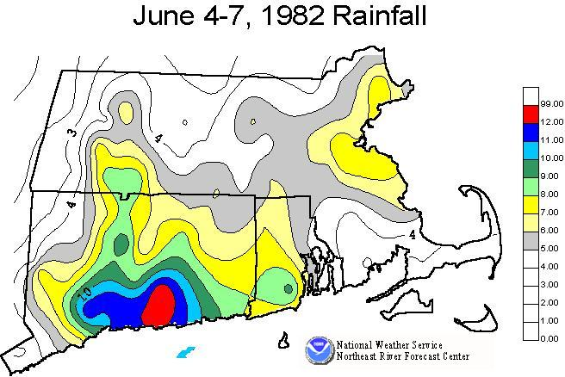
The 2.05″ of rain in Haddam on June 5th and 10.47″ on June 6th was also close to breaking the 24-hour state rainfall record held by Burlington from the August, 1955 flood of 12.77″. In North Lyme 16.00″ was recorded in the 3-day period.
Here are the USGS stream gauges that set record crests that day:
- Yantic River (Norwich) – 14.88ft (9/38 – 14.66ft)
- East Branch Eightmile River (North Lyme) – 10.22ft (1/79 – 8.81ft)
- Eightmile River (North Plain) – 11.12ft (1/79 – 8.24ft)
- Salmon River (East Hampton) – 14.40ft (1/79 – 12.67ft)
- Pendelton Hill Brook (No. Stonington) – 6.73ft (3/07 – 6.66ft)
- Indian River (Clinton) – 8.29ft (10/90 – 5.39ft)
- Quinnipiac River (Wallingford) – 14.02ft (1/79 – 12.93ft)
- Mill River (Hamden) – 9.53ft (6/92 -5.93ft)
All of the above records still stand! That’s an incredible number of river gauges to set records that are still standing. The damage from the flash flooding was also remarkable – particularly in Essex where dams failure devastated Centerbrook and Ivoryton.

